Professor Rajeev Dhawan | Carl R. Zwerner Chair of Economic Forecasting
Director, Economic Forecasting Center
J Mack Robinson College of Business
Georgia State University
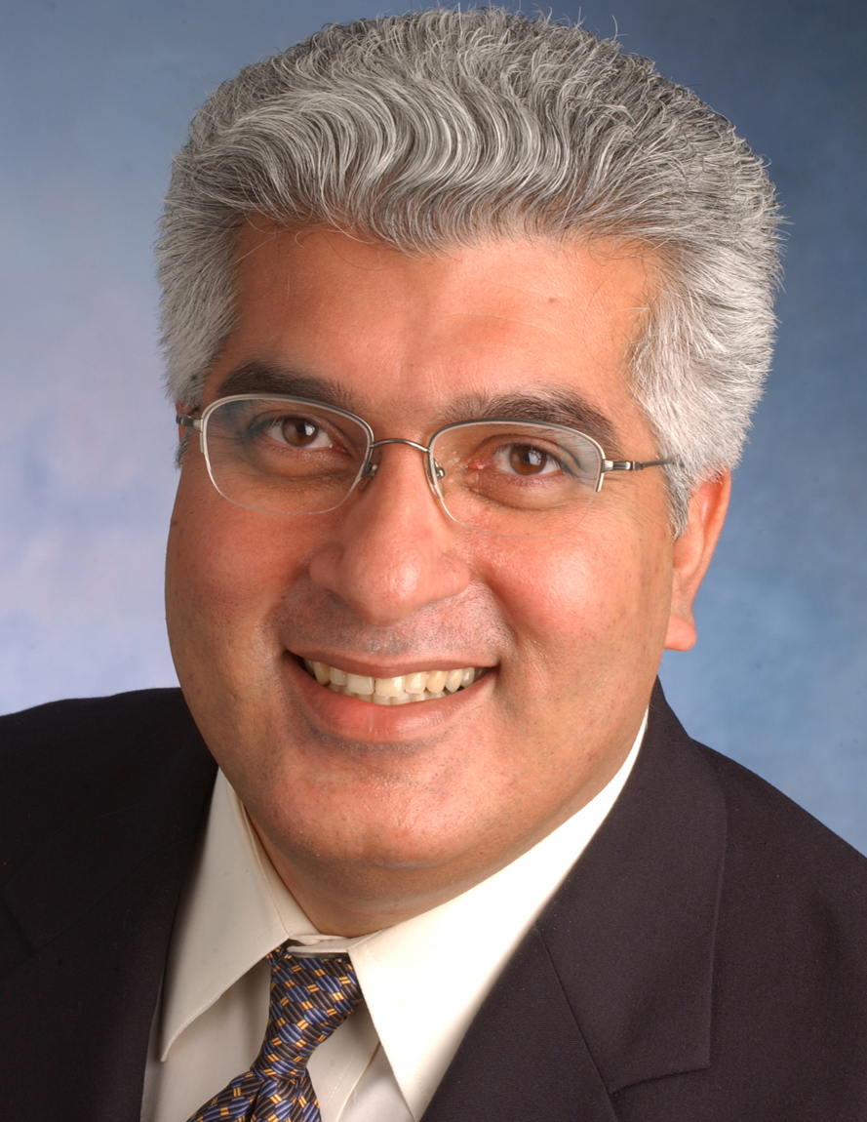

Rajeev Dhawan wears a dual hat as professor and holder of Zwerner Chair of Economic Forecasting and as Director of the Economic Forecasting Center at the Robinson College of Business at Georgia State University in Atlanta, Georgia. As director of one of the country’s premiere forecasting centers, Dhawan develops forecasts for the U.S., Southeast regional and local metro Atlanta economies. These forecasts are regularly published and presented to business executives and the media at the Center’s popular, well-respected quarterly forecasting conferences. Dhawan has received several awards for his forecasting accuracy, including Pulsenomics Crystal Ball award for most accurate home price predictions from 2013 to 2015, and the most accurate GDP forecast by Bloomberg News in 2005. The Bank One Economic Outlook Center at Arizona State University in 2003 named him the most accurate forecaster for US employment.
A sought-after international speaker, he has presented at conferences in Argentina, Australia, Canada, Chile, Dominican Republic, Dubai, France, Germany, Japan, Netherland, New Zealand, Spain, Sweden, Switzerland and across the U.S. As a consultant, he has been commissioned to prepare economic impact reports, home price forecast models, and provide public policy recommendations. Dhawan has served as an advisor to several local and state government agencies and numerous publicly-held companies. These companies include Coca-Cola, Georgia Power, Raymond James and Turner Broadcasting, among others. Dhawan has directed impact analysis studies for Amgen, Northrop Grumman, LA Development Corporation, the California Automobile Import Alliance and the California Energy Commission. He has served on the Georgia Governor’s Council of Economic Advisors since 2004.
Dhawan’s academic research analyzes U.S. business cycles with a special emphasis on the role of credit markets on growth and survival of small firms. His international industry productivity comparison study examined factors that enabled Toyota to dominate not only U.S. companies, but also its Japanese counterparts. In his recent work, Dhawan has quantified the role and importance of oil prices in U.S. business cycle fluctuations. His research has been published in peer-reviewed academic journals such as Management Science, Journal of Money, Credit and Banking, Review of Economic Dynamics, Economic Inquiry, and Journal of Economic Behavior and Organization among others. He is also the author of Firm Size, Financial Intermediation and Business Cycles which explores the effect of liquidity constraints on U.S. economic performance.
Prior to joining Georgia State University in the fall of 2000, he served as director of Econometric Forecasting at the Business Forecasting Project of the Anderson School of Business at UCLA. He has also taught at Pepperdine University and California State University at Long Beach. Dhawan earned a B.A. in Economics, with honors, from St. Stephen’s College in India, a M.A. in Economics from the Delhi School of Economics in India and a Ph.D. in Economics from the University of California at Los Angeles.

